NEWSLETTER FOR PASTORAL UNIT 1
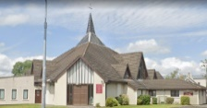 | St Nicholas Parish | St Mary’s Parish | 
Mass Times  Saturday Vigil 6.30pm Sunday 10.00am  Parish Live Streaming of Masses  from St Nicholas Church; log onto https://www.churchservices.tv/limerickstnicholas  or via the parish website; www.saintnicholasparish.ie |  | Mass Times  Saturday Vigil 5.00pm Sunday 11.30am  Monday to Friday Morning Mass 10.00am  Parish Live Streaming of Masses  from St Mary’s Church; log onto  https://www.churchservices.tv/limerickstmaryscatholicchurch

Saturday 21st & Sunday 22nd December 2024
Clergy Contacts
Fr Richie Davern 0872977500
Fr Gerard O’Leary 0879378685

Salesian Sisters 061-348510
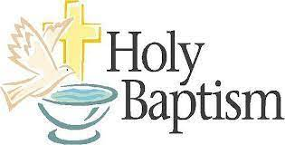
Baptisms are held in St Nicholas Church on the
4th Saturday in the month.
Baptisms are held in St Mary’s Church on the
1st & 3rd Saturday of the month at 4pm
Contact the Parish Office for more information and a Baptism Enrolment form.

St Nicholas Parish Office
Open Monday & Thursday 9.30am -1.30pm
Email: saintnicholasparishoffice@gmail.com
Phone: 061-341300
St Mary’s Parish Office
Open Wednesday & Friday 10.30am-1.00pm
Email:stmarysparishlk@outlook.com
Phone: 061-416300

You can contact the office if you wish to book a mass, order a cert or leave in your offerings to support your church. With Sympathy Mass cards & Mass Bouquet cards are available from the Parish Office

PARISH FACEBOOK:
www.facebook.com/Saintnicholasparish/
www.facebook.com/p/St-Marys-Catholic-Parish-Limerick

We encourage local groups in the area to avail of the Weekly Newsletter to promote upcoming events | 
Please send details for both parishes to saintnicholasparishoffice@gmail.com
with NEWSLETTER in the heading

Our Newsletter is printed every Thursday at 12noon. Items received after this time unfortunately cannot be included

Information and Support for Birth Mothers whose babies were placed for adoption may e found at www.birthinfo.ie or by calling TUSLA at +353818445500
 | Mass Intentions St Nicholas Church
Saturday 6.30pm
Pro Populo
Sunday 10.00am
Eamon Mulcahy (Anni)
Pauline Neville (2nd Anniv)
Peter Long (Anniv)

 | We offer our condolences to the families of  Kathleen ‘Kitty’ Barry R.I.P.  Ann Marie Casey R.I.P.  Ann Heal née Franey R.I.P.  Mary Patricia ‘Maudie’ Harrold R.I.P.  Patrick ‘Paddy’ McDonnell R.I.P  May they rest in eternal peace, Amen
Mass Intentions St Mary’s Church
Saturday 5.00pm
Bridie McNamara & son Pat (2nd & 30th Anniv)
Sean Reilly (Anniv), also remembering Kathleen, Patrick, Brendan & Philomena Braddish (Anniv)
Michael & Pat Hartnett (Anniv)
Maura Leamy (1st Anniv)
Michael Knapp Ryan (2nd Anniv)
Dan Ryan (9th Anniv) also remembering
John Ryan & Johnny Waters (Anniv)
Breeda Ryan (Birthday Remb.)
Sunday 11.30am
Thomas Garvey (M.M.)
Catherine Ryan (1st Anniv)
Betty Healy (22nd Anniv)
Russell, Callanan & Guerin families (Anniv)
Joe Heffernan (Anniv)
Mary Earls (24th Anniv)
Esther Morrissey (17th Anniv)
Sheila Shanahan (9th Anniv), husband Michael, son Eugene, daughter Eileen & Jack Sheehan (R.I.P.)

Prayer for when I can’t receive communion
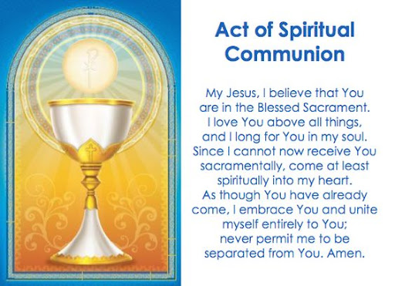

Prayer for the sick
Let us continue to pray for those who are ill at this time, those who are preparing for and awaiting results of tests and those in hospital. Lord Jesus, you are the true friend of all those who suffer anguish and pain in spirit, mind or body. Please share with them now the gift of your consoling love.

Parish Pastoral Council meet on a monthly basis. If you would like to raise any items/ issues or suggestions at a meeting, please send by email to the relevant Pastoral Council
St Nicholas Parish Pastoral council email: PPCStNicholas@gmail.com
St Mary’s Parish Pastoral Council email;
stmarysparishlk@outlook.com

 | The collection for weekend  14th & 15th December amounted to  €1746 in St Mary’s Church (including donations to Shrines)  €273 Diocesan Needs collection  St Nicholas collection figure will be printed next week.
We are very thankful for your continued generosity, and grateful for your loyalty and support.

ST VINCENT DE PAUL collection is held after Mass on the first weekend each month

Making a donation to the church by bank transfer
St Mary’s Church Account
IBAN: IE11 AIBK 9352 4794 4621 73 BIC: AIBKIE2D
St Nicholas Church Account
IBAN: IE84 BOFI 9045 9525 8744 17 BIC: BOFIIE2D

. St Nicholas Parish Meditation Group

We are taking a break for Christmas.
Meditation returns Tuesday, 14th January 2025
at 10.45am in St. Nicholas' Prayer Chapel.

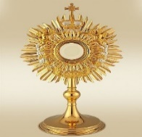 | ADORATION OF  THE BLESSED SACRAMENT  St Mary’s Church  Wednesday 10.30am-11.30am  (after Mass)

Students from St Munchins College will talk briefly at our Christmas Eve Mass in St Nicholas Church about their mission to walk part of the Camino in 2025 to raise much needed funds for the Cliona Foundation. They will hold a collection after this Mass and would be very grateful for any donation to their fundraiser.

St Nicholas Church Masses
Christmas Eve Vigil Mass 6.30pm
Christmas Day - Morning Mass 10.00am

St Mary’s Church Masses
Christmas Eve - Vigil Mass 5.00pm
Christmas Day – Morning Mass 11.30am
Thursday 26th – Mass 11.00am (note time change)
Friday 27th – Mass 10.00am

CHRISTMAS DUES: A Christmas Dues envelope has been distributed to houses throughout the parish, along with a Christmas card detailing our Christmas ceremonies. We are very aware that people are under financial pressure and sincerely thank all who are in a position to return their Dues envelope. The ’Dues’ collection is used to support the Clergy of our parish. Many thanks for your continued support.

Planned Giving Box of Envelopes for 2025
These are currently being distributed, but some houses do not have a letterbox and the box cannot be delivered. If you did not receive your box, please call to the sacristy after Mass as your box maybe here.

 | To our many groups of volunteers, who all do trojan work throughout the year, visible and invisible, Thank You.  We are so appreciative of the time you freely give, and your willingness to help out when needed.  We are very lucky in both St Nicholas Parish and in St Mary’s Parish to have such support from parishioners.

 | St Nicholas Parish Office  Closed from Thursday 19th Dec  Reopens Thursday 2nd Jan

Grow Mental Health- Friendly Community based peer support groups for anyone experiencing mental health issue through 12 Step Program of connection, hope, identity by empowering people to nurture their positive wellbeing by supporting personal growth through education and self-teaching. Henry Street, Limerick and Croom.
Contact Celia 086-1526966/ Danielle 086-1588626/Www.grow.ie

